P2. Database Design, Conceptual ERD

**Mission Statement:***Our mission is to develop a dependable database system that links clients with restaurants for efficient meal delivery. This includes precise order processing and tracking.*

1. Customer Service :

* Keep correct customer profiles and delivery addresses
* Keep track of your customers' orders.

1. Managing orders:

* Enable easy order placing and tracking
* Provide information on order status.
* Process secure payments.

1. Restaurant Operations:

* Menus and prices for restaurants
* Observe restaurant availability.

1. Coordination of deliveries:

* Driver status
* Track the status of your delivery.

ERD:

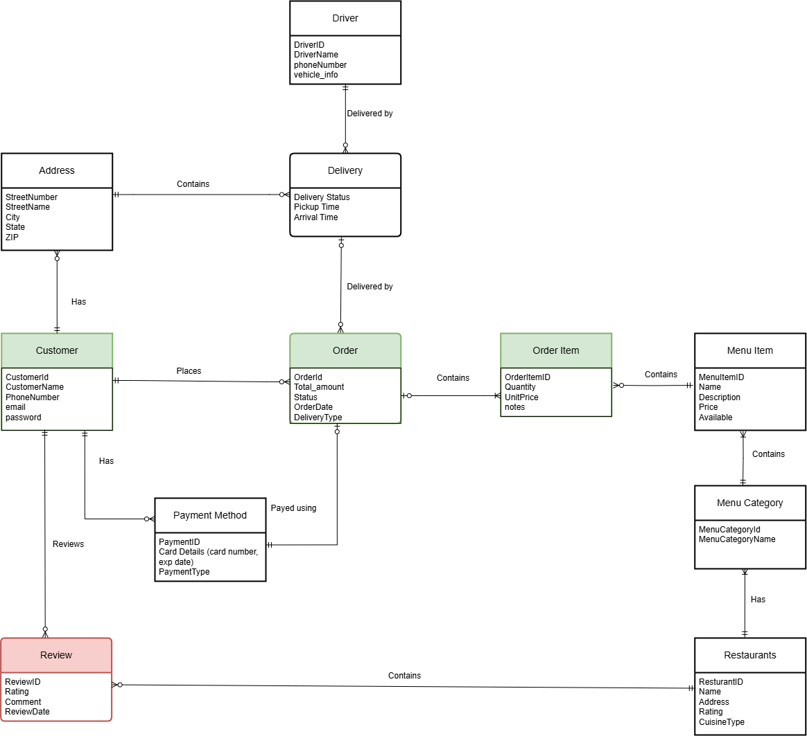

**Entities:**

1. Customer
   * **Description:**
     + A customer is a necessary part of the food delivery system since there are many customers who can place orders at restaurants
     + Related to Address, Order, PaymentMethod, and Review
     + A customer can have multiple addresses, can place orders, can have multiple payment methods, and can add reviews at restaurants
   * **Attributes:**
     + CustomerId, CustomerName, PhoneNumber, email, password
2. Review
   * **Description:**
     + A review is written by a customer. Each review is associated with only one customer and one restaurant, while a customer can write multiple reviews.
   * **Attributes:**
     + ReviewID, Rating, Comment, ReviewDate

1. PaymentMethod
   * **Description:**
     + A customer can have multiple payment methods associated with their account
     + Each order can have one or none PaymentMethod; if the order is for pickup, no PaymentMethod is required
   * **Attributes:**
     + PaymentID, Card Details (card number, exp date), PaymentType
2. Address
   * **Description:**
     + A customer can have multiple address associated with their account
     + If the order is made out for delivery then an address must be included, however not every Address on file needs to have a delivery or delivery history
   * **Attributes:**
     + StreetNumber, StreetName, City, State, ZIP
3. Order
   * **Description:**
     + The entity that links a customer, restaurant, and delivery person. It tracks the order status and timestamps, manages the total amount, and handles the delivery location.
   * **Attributes:**
     + OrderId, Total_amount, Status, OrderDate, DeliveryType
4. Delivery
   * **Description:**
     + The entity that manages the delivery process by linking an order to a driver. It tracks the delivery status, pickup time, and arrival time to ensure timely and efficient order fulfillment.
   * **Attributes:**
     + Delivery Status, Pickup Time, Arrival Time
5. Driver
   * **Description:**
     + Drivers are an important entity of this system since they are the mediator between the product and the customer
     + Related to the Delivery since they can do multiple deliveries for customers
   * **Attributes:**
     + DriverID, DriverName, phoneNumber, vehicle_info
6. OrderItem
   * **Description:**
     + The item that is part of the customer order and is linked to the corresponding MenuItem, can have multiple of the same MenuItem, basically a customized version of MenuItem
   * **Attributes:**
     + OrderItemID, Quantity, UnitPrice, notes
7. Restaurant
   * **Description:**
     + A key component that contains the products that customers order, can contain multiple categories (Lunch, Dinner, Breakfast, etc), and have multiple reviews
   * **Attributes:**
     + RestaurantID, Name, Address, Rating, CuisineType
8. MenuItem
   * **Description:**
     + The item that a customer can choose from a restaurant/store
   * **Attributes:**
     + MenuItemID, Name, Description, Price, Available
9. MenuCatagory
   * **Description:**
     + Restaurants have multiple categories of items that allow for easier browsing for customers
   * **Attributes:**
     + MenuCategoryId, MenuCategoryName

Back up(1/30's Version)

ERD:



**Entity:**

* Customer
  + A customer is a necessary part of the food delivery system since there are many customers who can place orders at restaurants
    - Related to Address, Order, PaymentMethod, and Review
    - A customer can have multiple addresses, can place orders, can have multiple payment methods, and can add reviews at restaurants
* Review
  + A customer can leave comments or rates to restaurants.
  + A review is written by a customer. Each review is associated with only one customer and one restaurant, while a customer can write multiple reviews.
* PaymentMethod
  + A customer can have multiple payment methods associated with their account
  + Each order can have one or none PaymentMethod; if the order is for pickup, no PaymentMethod is required
* Address
  + A customer can have multiple address associated with their account
  + If the order is made out for delivery then an address must be included, however not every Address on file needs to have a delivery or delivery history
* Order
  + Links customer, restaurant, and driver
  + Tracks order status and time
  + Handles delivery location
  + Manages total amount
* Delivery
  + Tracks delivery status
  + Links orders and drivers Relationships
  + Pickup and delivery times
  + Driver assignment
* Driver
  + Drivers are an important entity of this system since they are the mediator between the product and the customer
  + Related to the Delivery since they can do multiple deliveries for customers
* OrderItem

Quantity and price

Special notes/requests

Links to menu items

* + The item that is part of the customer order and is linked to the corresponding MenuItem, can have multiple of the same MenuItem, basically a customized version of MenuItem
* MenuItem
  + The item that a customer can choose from a restaurant/store
* MenuCatagory
  + Restaurants have multiple categories of items that allow for easier browsing for customers
* Restaurants
  + A key component that contains the products that customers order, can contain multiple categories (Lunch, Dinner, Breakfast, etc), and have multiple reviews

Part1 Note

**Mission Statement:**

*Our mission is to develop a dependable database system that links clients with restaurants for efficient meal delivery. This includes precise order processing and tracking.*

**Mission Objectives:**

* Customer Service
  + Keep correct customer profiles and delivery addresses
  + Keep track of your customers' orders.
* Managing orders
  + Enable easy order placing and tracking
  + Provide information on order status.
  + Process secure payments.
* Restaurant Operations
  + Menus and prices for restaurants
  + Observe restaurant availability.
* Coordination of deliveries
  + Driver status
  + Track the status of your delivery.

